1. Generator function:
A generator function in JavaScript is a special type of function that can be paused and resumed during its execution. It allows you to generate a sequence of values over time, and it's particularly useful for asynchronous programming, iterators, and other scenarios where you need to produce a series of values lazily.

=> Generator function return iterator

I. Create action watcher function:
it watches for an action to dispatch from any Component

II. Create actual function to handle async operation called on dispatch of above mentioned action unlike functions, generator functions do not run to completion.

unlike functions, generator functions do not run to completion.

function* test()
{
yield1,
yield2,
}

2. Redux saga
- Redux saga is a middleware library for managing side effects in a Redux application.
- It is build on generator function.
- Redux saga is based on the concept of effects yeild in generator function make next step.
- it is used in async action dispatch like api call, or dom access,side effects are not natural flow and work from react flow.
- It is a library which helps manage async action with generators it runs generator function for you.
- It gives you helper functions(take,put,call,delay etc) to interact with redux.

function* contatctApiCall(){
yeild take (‘start’)
yeild call(url,res)
}

take every: The take every effects listens for every occurance of a specified action and run a saga in response

take latest: the takelatest effects cancels any previous instances of a saga and runs only the latest instances in the response to a specified action.

put: the put effects dispatches an action to the redux store

Redux-saga setup
Version
redux : 4.1.1 & redux-saga : 1.2.3 & react-redux: 8.0.5

index.js
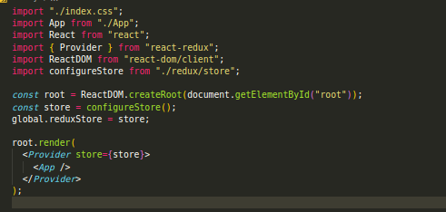
store.js
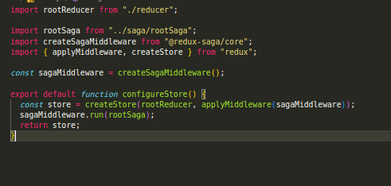
.
rootSaga.js
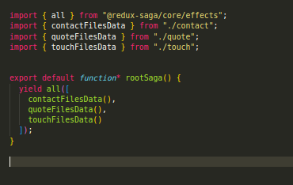
rootReducer.js
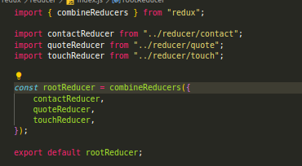

saga.js
